PIZZA SALES SQL QUERIES
- KPI’S
- TOTAL REVENUE :
Select Sum(Total_Price) As TOTAL_REVENUE From Pizza_Sales;
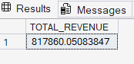
- AVERAGE ORDER VALUE :
Select Sum(Total_Price) / Count (Distinct Order_id) As AVG_ORDER_VALUE from Pizza_Sales;
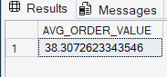
- TOTAL PIZZAS SOLD :
Select Sum(Quantity) As TOTAL_PIZZAS_SOLD from Pizza_Sales;
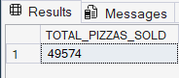
- TOTAL ORDERS :
Select Count(Distinct Order_id) As TOTAL_ORDERS From Pizza_Sales;
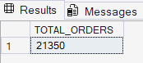
- AVERAGE PIZZAS PER ORDER :
Select Cast(Cast(Sum(Quantity) As Decimal(10,2)) /
Cast(Count(Distinct Order_id) As Decimal(10,2)) As Decimal (10,2)) As AVG_PIZZAS_PER_ORDER From Pizza_Sales;
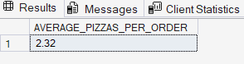
- CHARTS REQUIREMENT

- DAILY TREND FOR TOTAL ORDERS :
Select DATENAME(DW,Order_Date) As ORDER_DAY, Count(Distinct Order_Id) As TOTAL_ORDERS From Pizza_Sales
Group By DATENAME(DW, Order_Date);
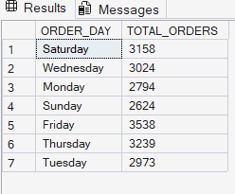
- HOURLY TREND FOR ORDERS :
SELECT DATEPART(HOUR, ORDER_TIME) AS ORDER_HOURS, COUNT(DISTINCT ORDER_ID)
AS TOTAL_ORDERS
FROM PIZZA_SALES
GROUP BY DATEPART(HOUR, ORDER_TIME)
ORDER BY DATEPART(HOUR, ORDER_TIME);
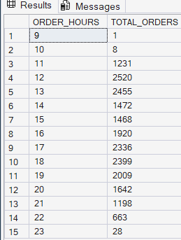

- MONTHLY TREND FOR TOTAL ORDERS :
SELECT DATENAME(MONTH, ORDER_DATE) AS MONTH_NAME , COUNT(DISTINCT, ORDER_ID) AS TOTAL_ORDERS FROM PIZZA_SALES
GROUP BY DATENAME(MONTH, ORDER_DATE) ORDER BY TOTAL_ORDERS DESC;
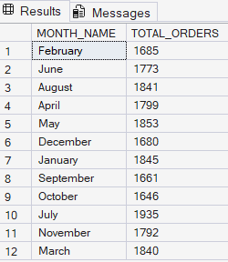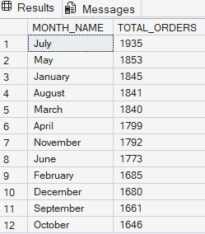
- PERCENTAGE OF SALES BY PIZZA CATEGORY :
SELECT PIZZA_CATEGORY, SUM(TOTAL_PRICE) AS TOTAL_PRICE, SUM(TOTAL_PRICE) * 100 / (SELECT SUM(TOTAL_PRICE) FROM PIZZA_SALES) AS PERCENTAGE_TOTAL_SALES
FROM PIZZA_SALES
GROUP BY PIZZA_CATEGORY;
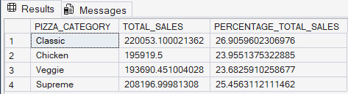
- PERCENTAGE OF SALES BY PIZZA SIZE :
SELECT PIZZA_SIZE, CAST(SUM(TOTAL_PRICE) AS DECIMAL(10,2)) AS TOTAL_SALES ,CAST(SUM(TOTAL_PRICE) * 100 /
(SELECT SUM(TOTAL_PRICE) FROM PIZZA_SALES ) AS DECIMAL (10,2)) AS PERCENTAGE_TOTAL_SALES
FROM PIZZA_SALES
GROUP BY PIZZA_SIZE
ORDER BY PERCENTAGE_TOTAL_SALES DESC;
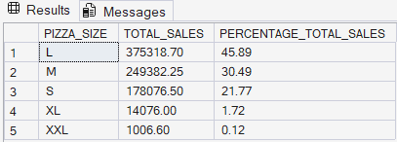
SELECT PIZZA_SIZE, CAST(SUM(TOTAL_PRICE) AS DECIMAL(10,2)) AS TOTAL_SALES ,CAST(SUM(TOTAL_PRICE) * 100 /
(SELECT SUM(TOTAL_PRICE) FROM PIZZA_SALES WHERE DATEPART(QUARTER , ORDER_DATE) = 1) AS DECIMAL (10,2)) AS PERCENTAGE_TOTAL_SALES
FROM PIZZA_SALES
WHERE DATEPART(QUARTER , ORDER_DATE) = 1
GROUP BY PIZZA_SIZE
ORDER BY PERCENTAGE_TOTAL_SALES DESC;
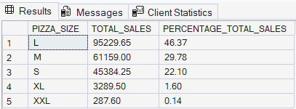
- TOP 5 BEST SELLERS BY REVENUE, TOTAL QUANTITY AND TOTAL ORDERS :
SELECT TOP 5 PIZZA_NAME, SUM(TOTAL_PRICE) AS TOTAL_REVENUE FROM PIZZA_SALES
GROUP BY PIZZA_NAME
ORDER BY TOTAL_REVENUE DESC;
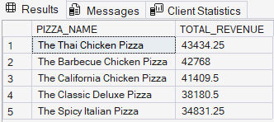
SELECT TOP 5 PIZZA_NAME, SUM(QUANTITY) AS TOTAL_QUANTITY FROM PIZZA_SALES
GROUP BY PIZZA_NAME
ORDER BY TOTAL_QUANTITY DESC;
SELECT TOP 5 PIZZA_NAME, COUNT(DISTINCT ORDER_ID) AS TOTAL_ORDERS FROM PIZZA_SALES
GROUP BY PIZZA_NAME
ORDER BY TOTAL_ORDERS DESC;
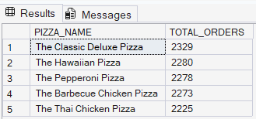

- BOTTOM 5 BEST SELLERS BY REVENUE , TOTAL QUANTITY AND TOTAL ORDERS :

SELECT TOP 5 PIZZA_NAME, SUM(TOTAL_PRICE) AS TOTAL_REVENUE FROM PIZZA_SALES
GROUP BY PIZZA_NAME ORDER BY TOTAL_REVENUE ASC;
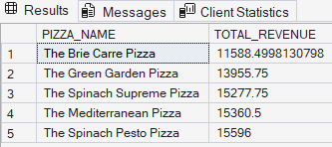
SELECT TOP 5 PIZZA_NAME, SUM(QUANTITY) AS TOTAL_QUANTITY FROM PIZZA_SALES
GROUP BY PIZZA_NAME
ORDER BY TOTAL_QUANTITY ASC;
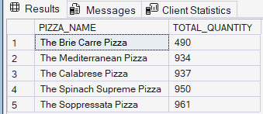
SELECT TOP 5 PIZZA_NAME, COUNT(DISTINCT ORDER_ID) AS TOTAL_ORDERS FROM PIZZA_SALES
GROUP BY PIZZA_NAME
ORDER BY TOTAL_ORDERS ASC;
